KELLY-O'BRIEN, Jacob

Brief user manual written for the Arduino Magnetometer project created for ACNS by the Year in Industry Student Jacob Kelly-O’Brien

Adruino Magnetometer Manual

ANSTO - ACNS

Contents

Introduction 2

Safety Precautions 2

Components and Requirements 2

Hardware Setup 3

Software Installation 5

Introduction

Welcome to the Arduino Magnetometer User Manual. This guide will help you set up, program, and interpret data from your magnetometer sensor connected to an Arduino microcontroller. This Arduino project was created as a cheap, efficient way to measure magnetic field inside instruments at ANSTO ACNS. This project was created by Jacob Kelly-O’Brien, Year in Industry student, managed by Dr Andrew Manning.

The project is a small 3D printed box with 2 buttons (on/off and recording/not recording) and a LCD screen for results. The project contains a magnetometer, a Time of Flight Sensor, a Real Time Clock, a RP2040 Arduino and a battery pack.

Safety Precautions

Handle electronic components with care.

Avoid exposing the magnetometer to strong magnetic fields beyond its rated capacity (+- 50G).

Disconnect power when modifying the circuit.

Keep the device away from moisture.

When not in use, store the RTC in a li-po guard bag, as the RTC contains a small lithium Polymer battery.

# Components and Requirements

|  |  |  |  |  |
| --- | --- | --- | --- | --- |
| Item Name | Use | Type | Cost | Link |
| Adafruit Feather RP2040 Adalogger | To control the external parts, as well as be the hub for all the power supply. | Microcontroller (AdaFruit) | $27.70 | <https://core-electronics.com.au/adafruit-feather-rp2040-adalogger-8mb-flash-with-microsd-card-stemma-qt-qwiic.html> |
| Adafruit VL53L4CX TOF Sensor | Time of Flight Sensor to measure the distance. Will be used to measure and plot the magnetic field of the instrument (Field Strength vs distance) | Time of Flight Sensor | $27.30 | <https://core-electronics.com.au/adafruit-vl53l4cx-time-of-flight-distance-sensor-1-to-6000mm-stemma-qt-qwiic-1.html> |
| Adafruit LIS2MDL | Magnetometer used to measure the magnetic field of the instrument | Magnetometer | $14.65 | <https://core-electronics.com.au/adafruit-triple-axis-magnetometer-lis2mdl-stemma-qt-qwiic.html> |
| Adafruit Grayscale 1.5 128x128 OLED graphic display | Small OLED Screen to display the magnetic field & the distance measured. | OLED Screen | $45.25 | <https://core-electronics.com.au/adafruit-grayscale-1-5-128x128-oled-graphic-display-stemma-qt-qwiic.html?gad_source=1&gclid=CjwKCAjwoJa2BhBPEiwA0l0ImFDuOuBXLOAJwonDeAgcxDvAP6zxY9NQkK8MyG5BQJ-0EMHc65IVoBoCGHwQAvD_BwE> |
| Stemma QT JST SH 4-pin Cable (50mm) | Short 4pin cable to connect stemma QT Compatible parts | Cable Connector | $1.90 | <https://core-electronics.com.au/stemma-qt-qwiic-jst-sh-4-pin-cable-50mm-long.html> |
| Stemma QT JST SH 4-pin cable (100mm) | Medium Length 4pin cable to connect stemma QT compatible Parts | Cable connector | $1.95 | <https://core-electronics.com.au/checkout/cart/> |
| LiPo Safety Battery Bag | Battery bag to safely store the battery | Battery Safety Bag | $5.95 | <https://core-electronics.com.au/lipo-safety-battery-bag.html> |
| SPTS Pushbutton – Black Actuator – Latching | Button to control the recording features | Button | $2.45 | <https://www.jaycar.com.au/spst-pushbutton-black-actuator-latching/p/SP0718> |
| Battery Bank 5000mAH | Power source | Battery | $24.96 | <https://core-electronics.com.au/battery-bank-5000mah.html> |
| Adafruit PCF8523 Real Time Clock Breakout Board | Used for keeping the time to save the data files | Real-Time-Clock | $10.20 | <https://core-electronics.com.au/adafruit-pcf8523-real-time-clock-breakout-board-stemma-qt-qwiic.html> |
| USB-C In-Line Power Switch Cable for Raspberry Pi 4 | Used for turning the device on and off | USB power switch cable | $3.70 | <https://core-electronics.com.au/micro-usb-c-in-line-power-switch-cable-for-raspberry-pi-4.html> |

# Hardware Setup

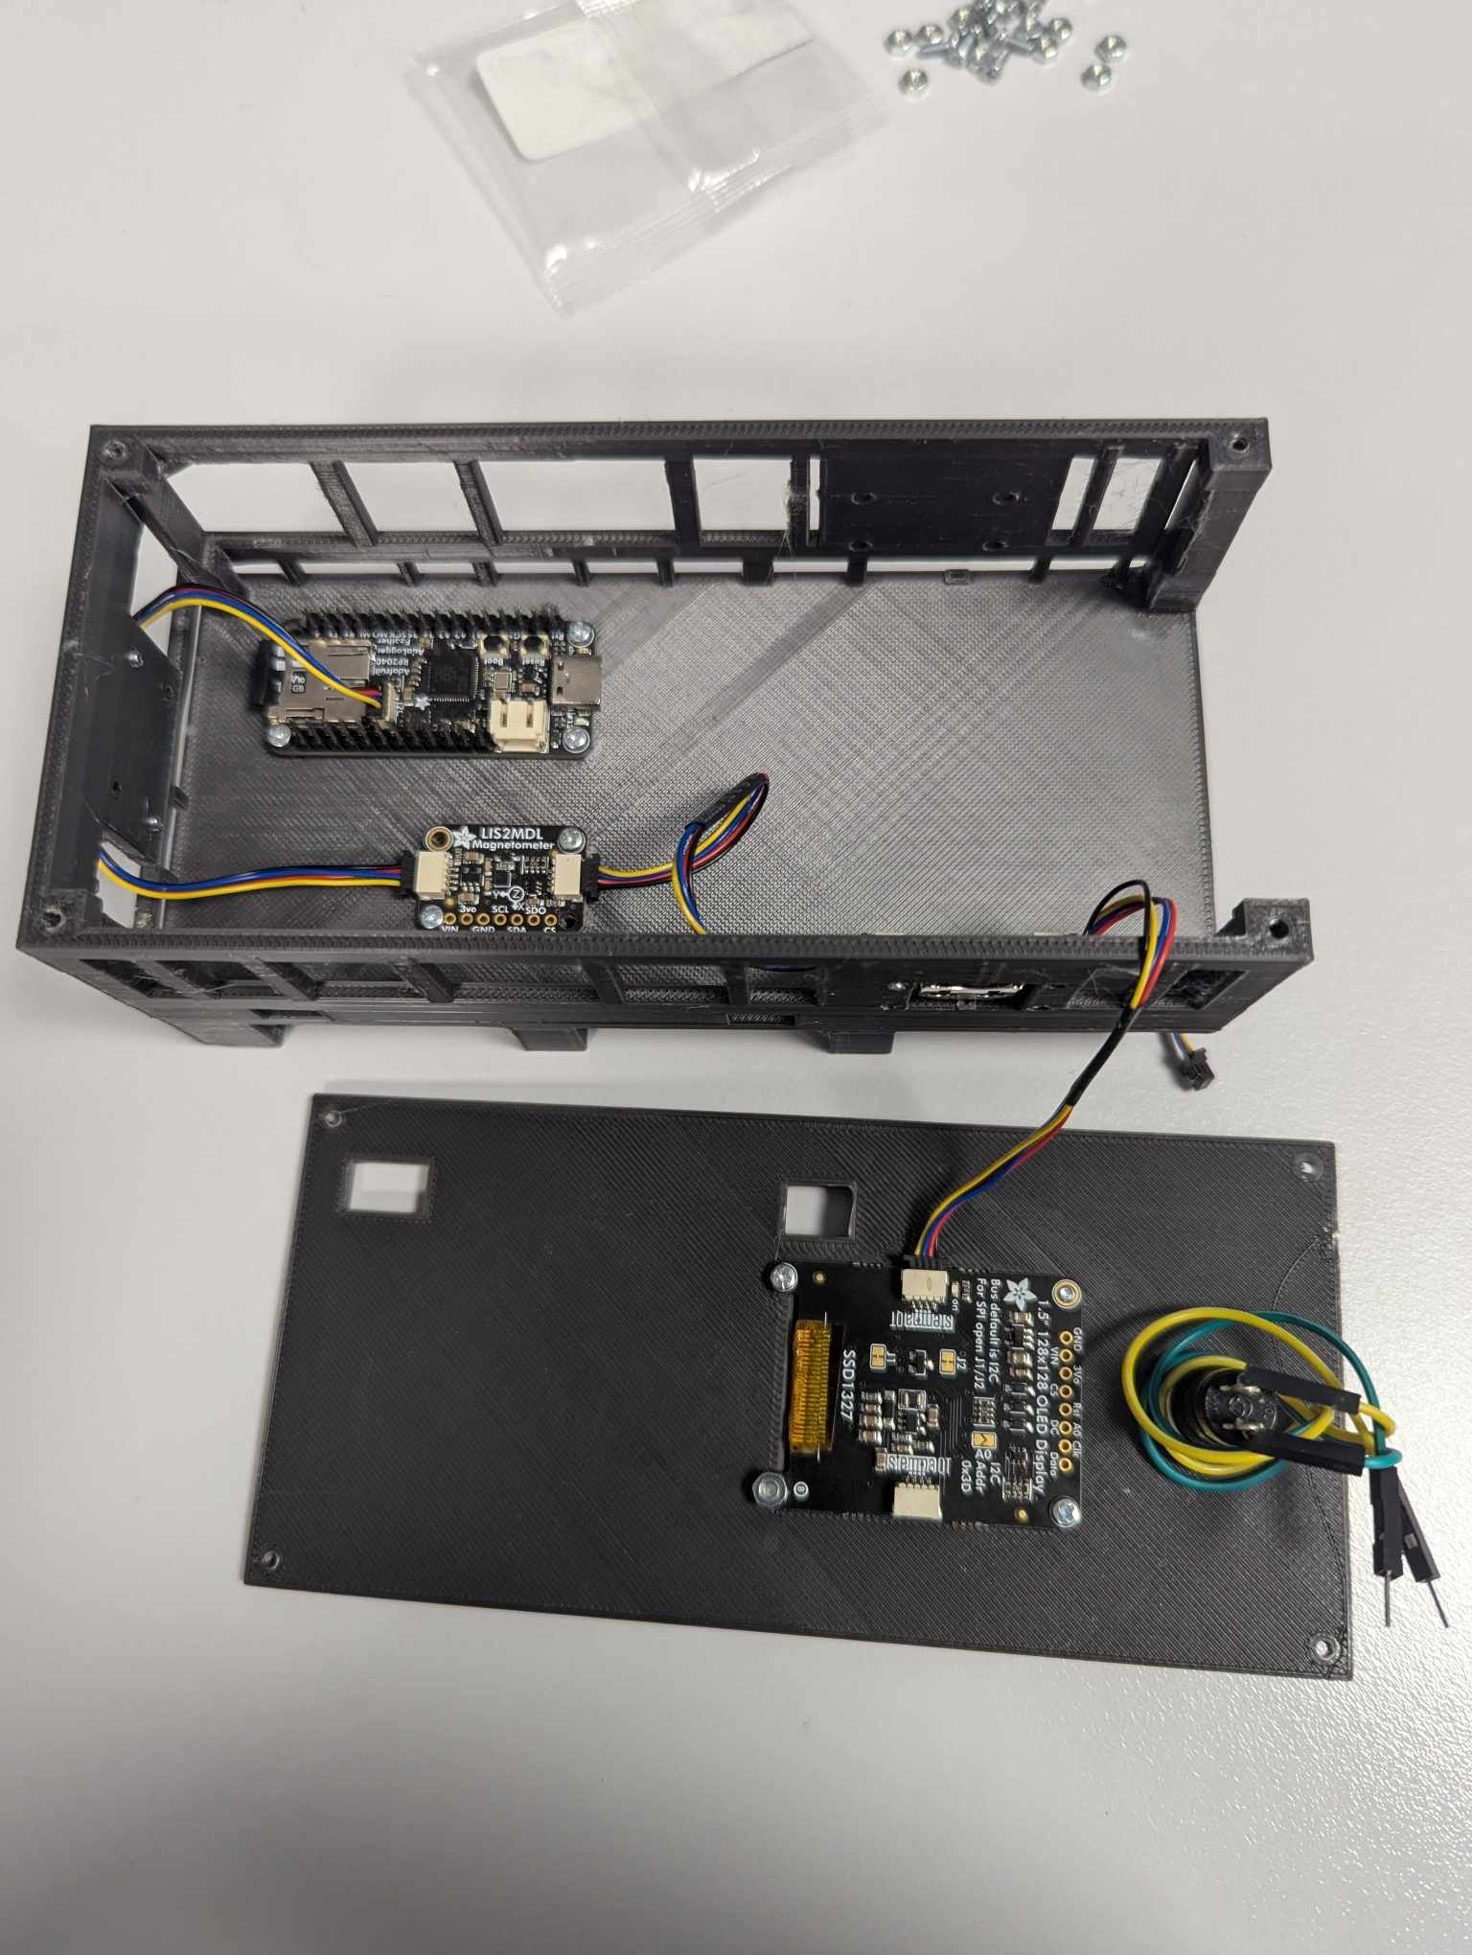The components on the board should be screwed in using 2.5mm screws. The component slots can be seen labelled in the below image.

RP2040

TOF

LI2MDL

RTC

Wiring the Arduino parts: Wiring the Arduino parts is very simple, as they plug into each other daisy loop style using the Stemma QT cables. The easiest wiring assembly is as follows:

1: Arduino – 2: Time of Flight Sensor – 3: Magnetometer – 4: Real Time Clock- 5: OLED screen

Wiring the battery and button Switch: The battery inline power switch needs to be put through the top slots, with the male port of the power switch connected directly to the Arduino. The Female port should be connected to the battery extension cable and tucked away. The power recording button should be connected to the Arduino using small cables. The button has two cables, connecting one with the ‘5’ slot on the RP2040 (next to SCL), with the other cable being connected to the ‘gnd’ slot. These cables do not have a specific connection point and can be intertwined with each other.

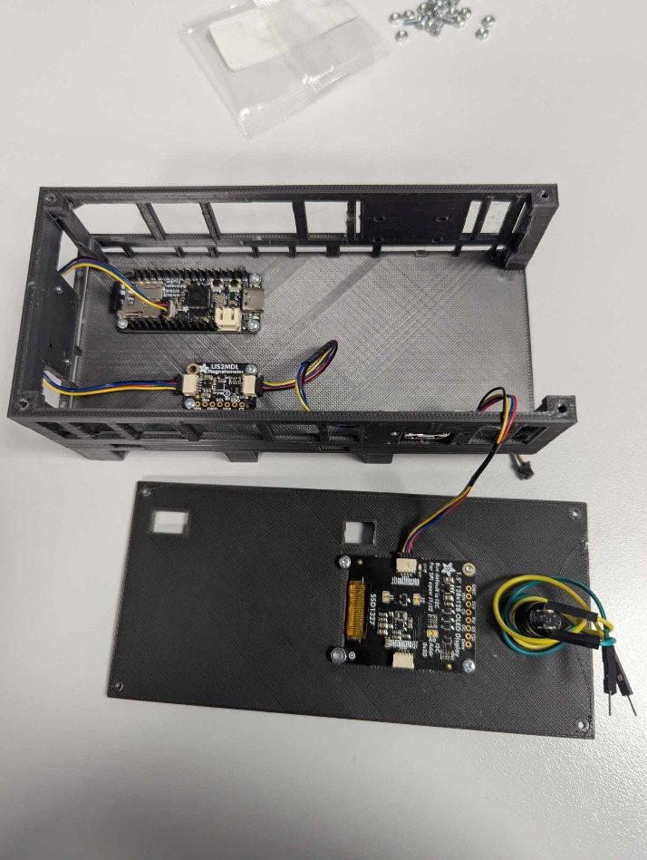

5

4

3

2

1

# Software Installation

To install the required software, the RP2040 needs to be connected via USB-C cable to the Arduino IDE computer software. In the Boards Manager, the RP2040 needs to be installed. For the library manager, the following libraries should be installed: SD by Arduino, AdafritBusIO by Adafruit, Adafruit EPD by Adafruit, Adafruit GFX Library by Adafruit, Adafruit HX8357 by Adafruit, Adafruit ILI9341 by AdaFruit, Adafruit ImageReader Library by Adafruit, Adafruit LIS2MDL by Adafruit, Adafruit LSM303 Accel by Adafruit, Adafruit NeoPixel by Adafruit, Adafruit PWM Servo Driver Library by Adafruit, Adafruit SH110X by Adafruit, Adafruit SPIFlash by AdaFruit, Adafruit SSD1306 by Adafruit, Adafruit SSD1327 by Adafruit, AdafruitSSD1331 OLED Driver Library by Adafruit, Adafruit SSD1351 Library by Adafruit, Adafruit ST7735 and ST7789 Library by Adafruit, Adafruit STMPE619 by Adafruit, Adafruit TSC2007 by Adafruit. Adafruit Touchscreen by Adafruit, Adafruit Unified Sensor by Adafruit, Adafruit Seesaw Library by AdaFruit, RP2040_SD by Bill Greiman, RTClib by Adafruit, STM32duino by SRA, STM32Duino VL54L4XX by STMicroelectronics, and SDFat – Adafruit Fork by bill Greiman.

Once all the libraries have been installed, in the Arduino IDE, you can simply run the code and upload it to the RP2040 board.

# Troubleshooting

There are built-in factors to aid the trouble shooting of the device. Below is a table of the errors and how to fix them.

|  |  |  |
| --- | --- | --- |
| Error | Cause | Fix |
| Unable to initialize OLED | OLED not correctly loading | Ensure cables are connected correctly, check the code for any bugs. |
| No LIS2MDL Found | Magnetometer Not correctly attached | Ensure the cables to the magnetometer are correctly attached. |
| No SDcard Found | The SD card is not correctly in the rp2040 | Ensure the SD card was correctly inserted into the magnetometer |
| No RTC found | The real-time-clock was not attached correctly | Ensure the cables to the RTC are correctly attached |
| Press Button & Restart to Continue | The button is set to recording before initialization | Click the record button, then reset the device by disconnecting and reconnecting the power. |